**KIYALA HIGH SCHOOL**

**END OF TERM ONE ASSESSMENT TEST -2024**

**HISTORY AND POLITICAL EDUCATION**

**Paper 1**

**S.4**

**2 Hours**

**INSTRUCTIONS**

* This paper consists of two sections **A** and **B**. It has ***four***examination items.
* Section **A** is ***compulsory***.
* Answer **one** item from section **B**
* Any additional item answered will not be ***scored***

**SECTION A**

*Attempt* **all the items** *in this section*

**Item 1**

Today, there are many international migrants in Uganda such as the Chinese, Indians, Sudanese, Somalis, Congolese, Kenyans, Americans, Tanzanians among others.

However, the coming of these migrants have made the available resources scarce leading to the tensions between the Ugandan communities and the migrants over access to services such as education, business, healthcare services among others.

***Task***

With specific examples referring to the international migrations, why do you think there is a lot of increasing migrants in Uganda today. ***(10 scores)***

**Item 2**

The government of Uganda developed the Parish Development Model as a means to transform households from a subsistence economy to a money economy. This catered for the disabilities, elderly, the youth and many others who were part of the beneficiaries of the program. It was structured to change the mindset and cross gender issues, improve on the peoples social services and financial inclusion so as to improve on the people’s economies and standards of living.

***Task***

Prepare a written speech that the minister of local government will use ***to educate and sensitize*** the masses about how the whole plan or program will be run and achieved by all the beneficiaries. ***(10 scores)***

**SECTION B**

*Attempt* **only one** *item in this section*

**Item 3**

Despite of the political independence attained by the African states, still the political

instability in some countries remain as a great challenges for the African development.

***Task***

Using your knowledge as a form four candidate, ***assess the root causes*** of this problems in Africa and ***also state how*** the African communities are affected with this problem. ***(10 scores)***

**Item 4**

**In 2020-2021 Budget**, the Kampala Capital City Authority Set up 9 billion shillings to

punch up the potholes on different city roads. The Minister for Kampala Betty Amongi told

the Journalists at Uganda Media center that they had seeked permission from the Minister

of Finance to have all the meant for infrastructures works that were dedicated to the

emergency road repairs. Betty Amongi said that 38 roads, 8 were in Rubaga division, 5 in

Nakawa division, 8 in Makindye division including salaama road which is in bad condition,

8 in Kawempe division and 9 roads in central division were to be worked on.

**Unfortunately**, in **2020-2021 Budget** the Minister of Finance Matia Kasaijja told the

parliament committee that the money meant for repairing these roads was not there. The

parliamentary committee chairperson was shocked with his members on the committee.

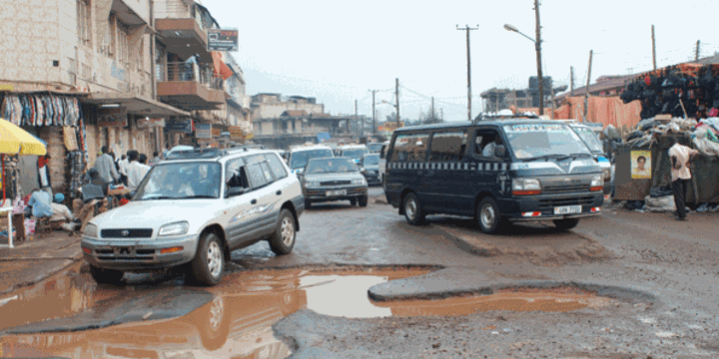

***Task***

1. Why do you think the Government of Uganda prioritizes the road construction and

maintenance through better allocation of funds in the budget? ***(08 scores)***

1. Explain the challenges faced in the road maintenance in your country? ***(07 scores)***

**END**